**Lesson 10 Demo 1**

**Building a Dashboard and Dashboard Actions**

**Business Scenario:** A retail company is strategizing to improve business in low-performing areas as well as to extend its services in areas that contribute the maximum toward sales and profit. For this, John Douglas, CEO of the company, needs to keep an eye on region, state, category, subcategory, sales, profit ratio, and profit. This will help him determine the regions and states eligible for attractive discount strategies.

* What is the overall profit of the Central region?
* In the South Region, which subcategory recorded the lowest sales?

**Overview:**

* Design the required sheets
* Create a dashboard using these sheets in the workbook
* Add a Filter action on the Region and State Analysis sheet

The result should resemble the image given below:

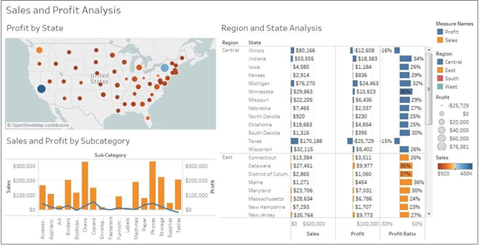

**Detailed Instructions:**

1. Open **Tableau 10.x** (You can go to Start Menu -> All Programs -> Tableau 10.x). On the home page, under **Connect**, under **To a File**, click **Microsoft Excel**

1. Browse and connect to the **Sample - Superstore** excel file

NOTE: The dataset is provided in assisted practice

3. To create a view, drag **Region** and **State** dimensions to Rows, and **Sales, Profit,** and **Profit Ratio** measures to Columns

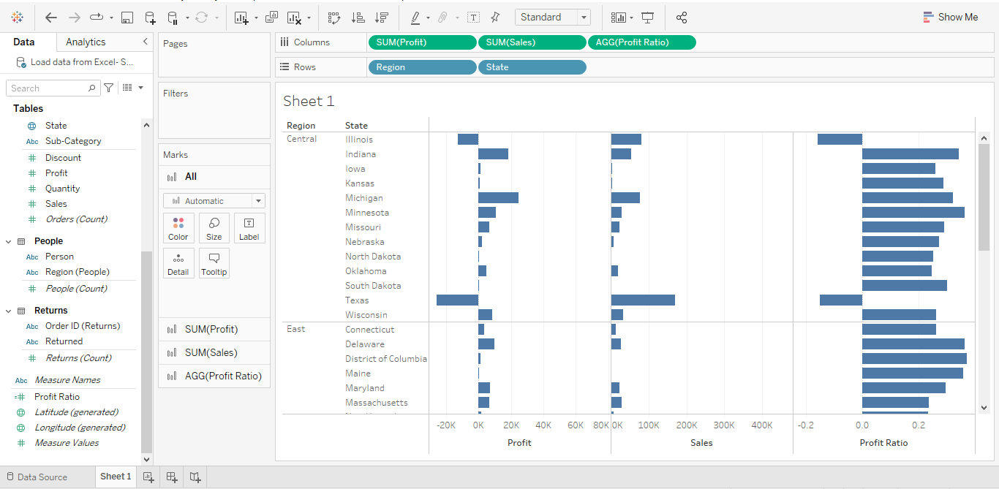

**4. Color** all the measures by **Region**

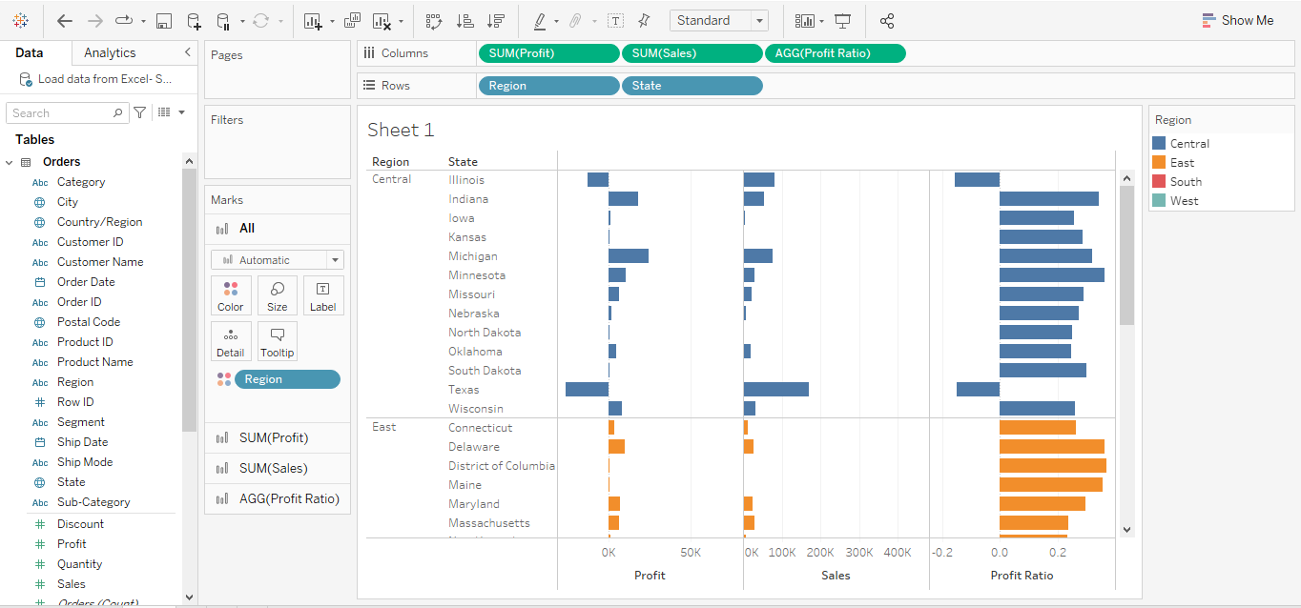

5. Enable **labels** using **Marks Card**

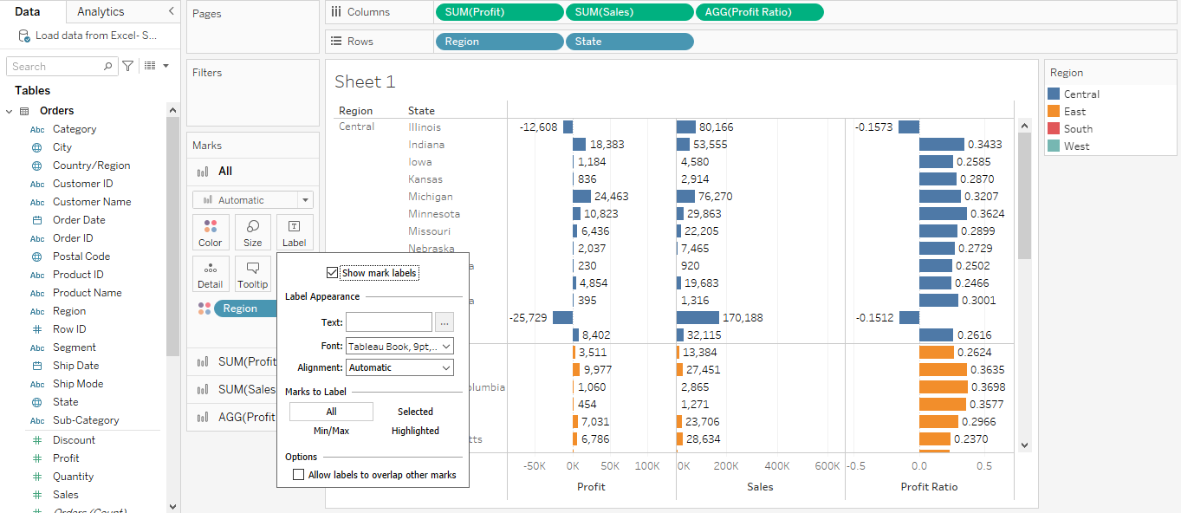

6. Rename the sheet as **Region and State analysis**

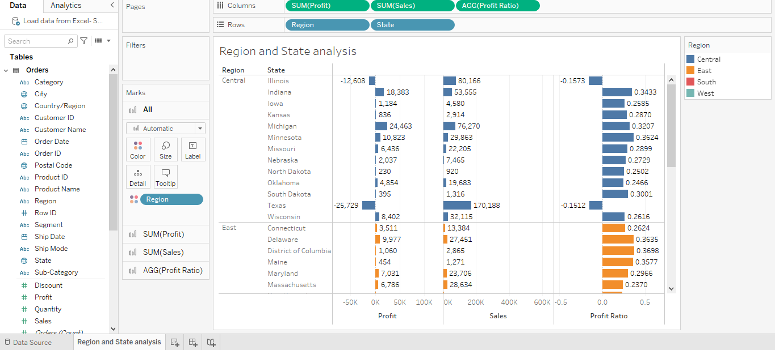

7. To create a view, navigate to a new sheet

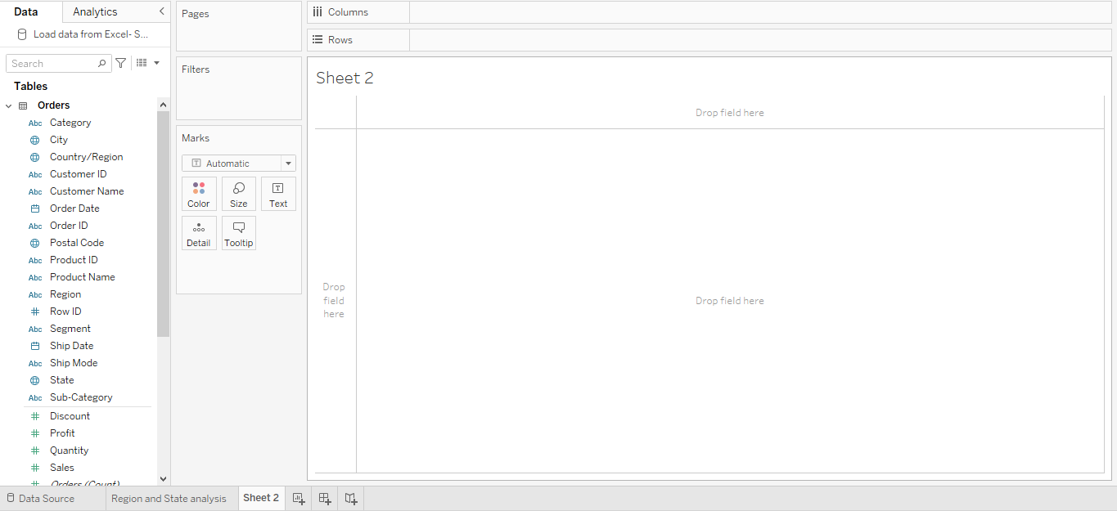

8. Create a symbol map with the **State** dimension

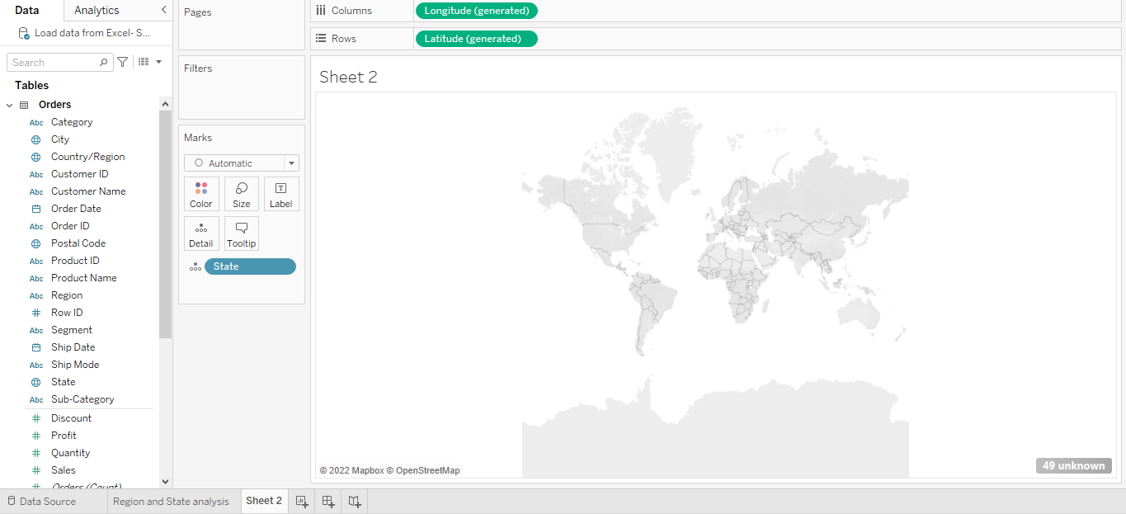

9. Drag the **Sales** measure to **Color**

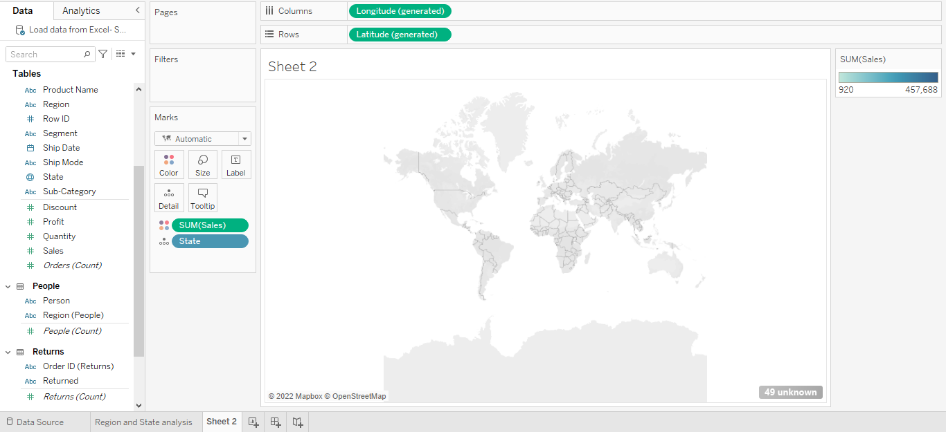

10. Drag the **Profit** measure to **Size**

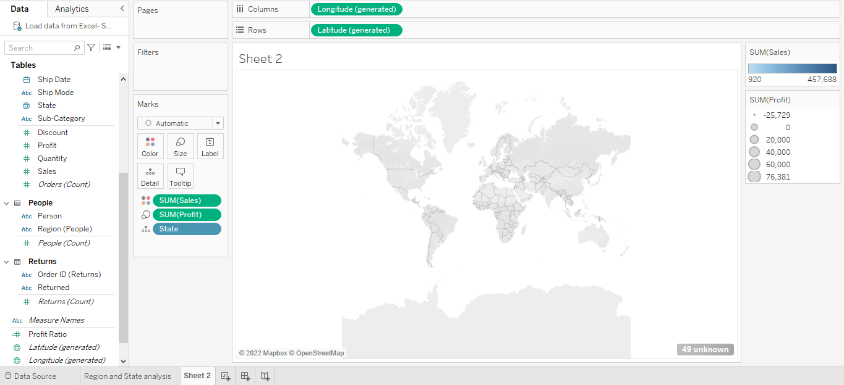

11**.** To change the color, click **Color > Edit Colors**

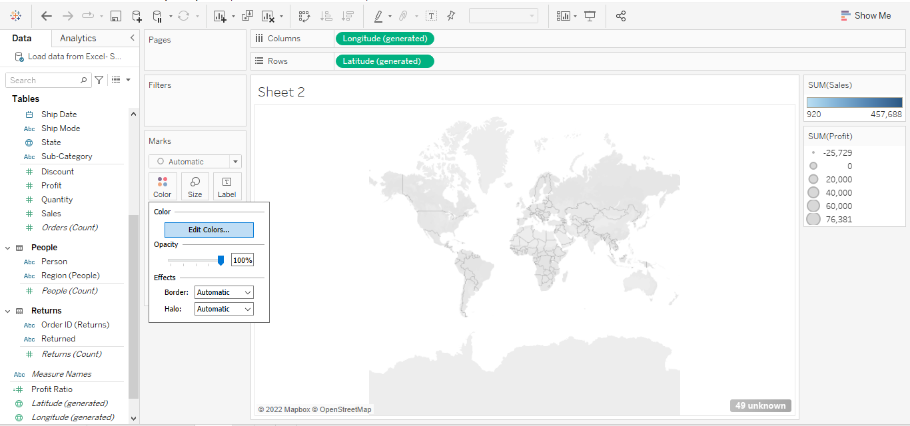

12. From the **Edit Colors** palette, select **Orange-Blue Diverging**

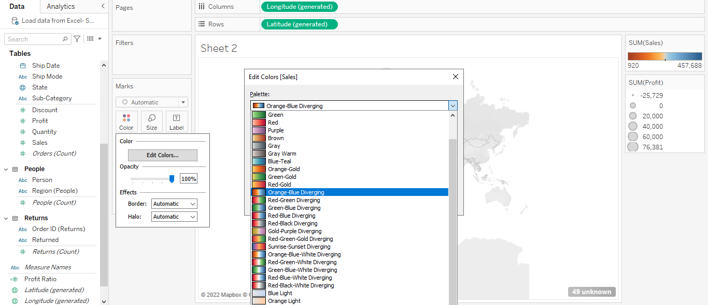

13. Click **OK**

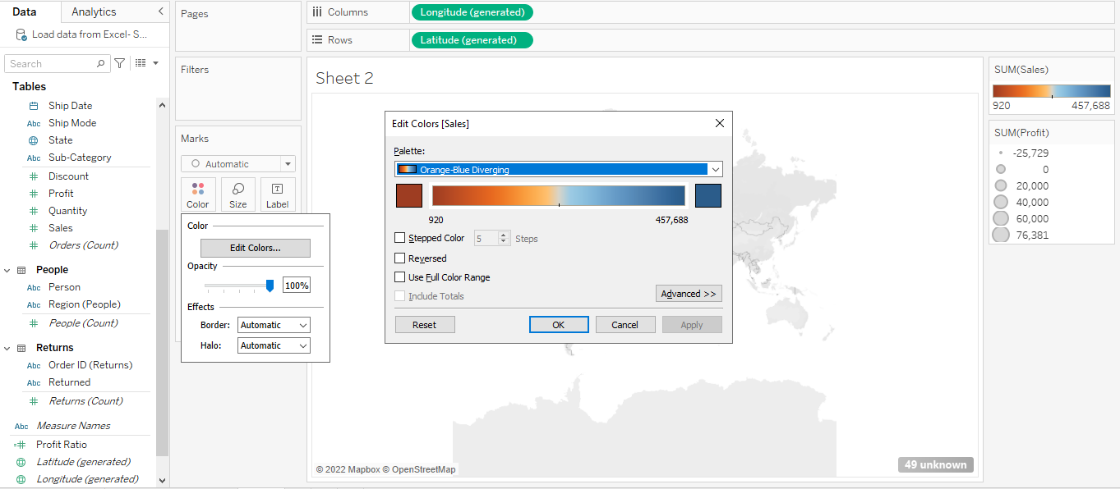

14.Rename sheet as **Profit by State**

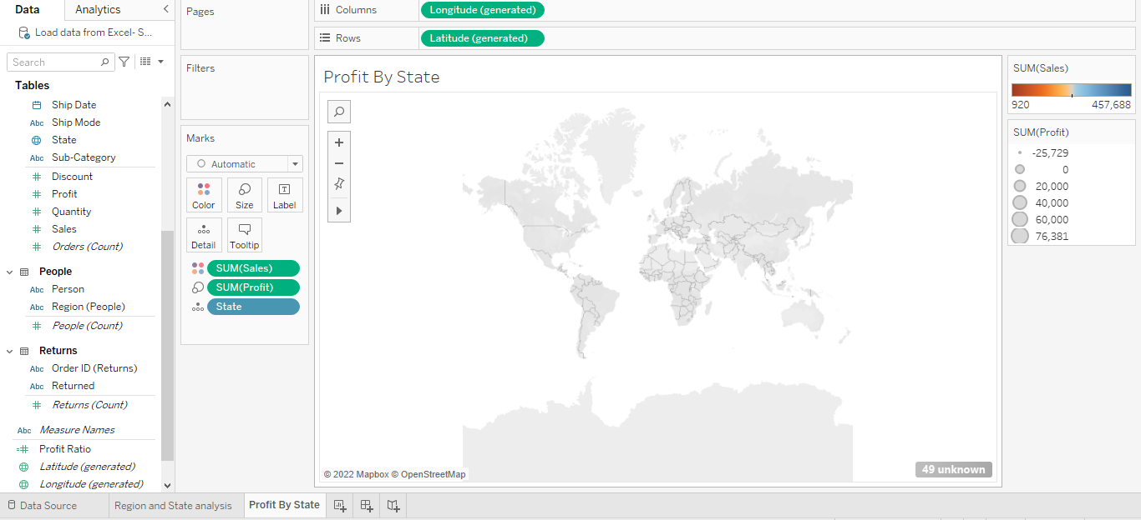

15. Create a new sheet

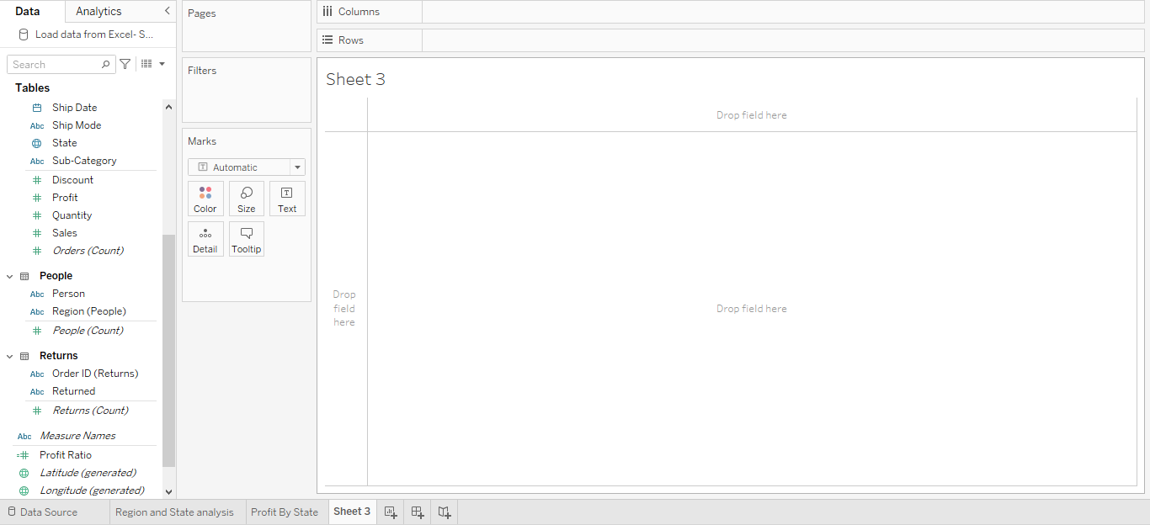

16. Create a dual-axis combination chart with **Sub-Category**, **Sales**, and **Profit**

17. Drag the **Sub-Category** dimension to Columns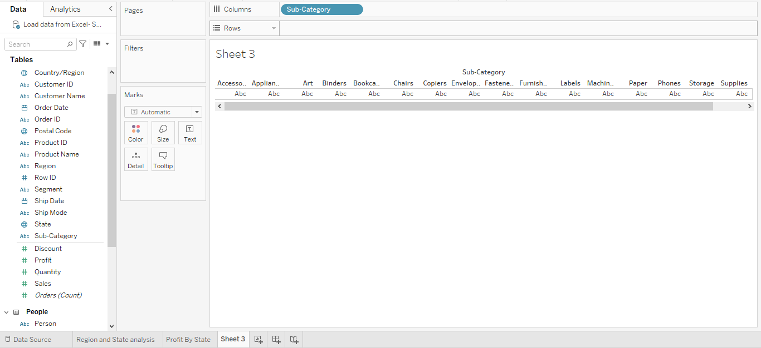

18. Drag the **Sales** and **Profit** measures to **Rows**

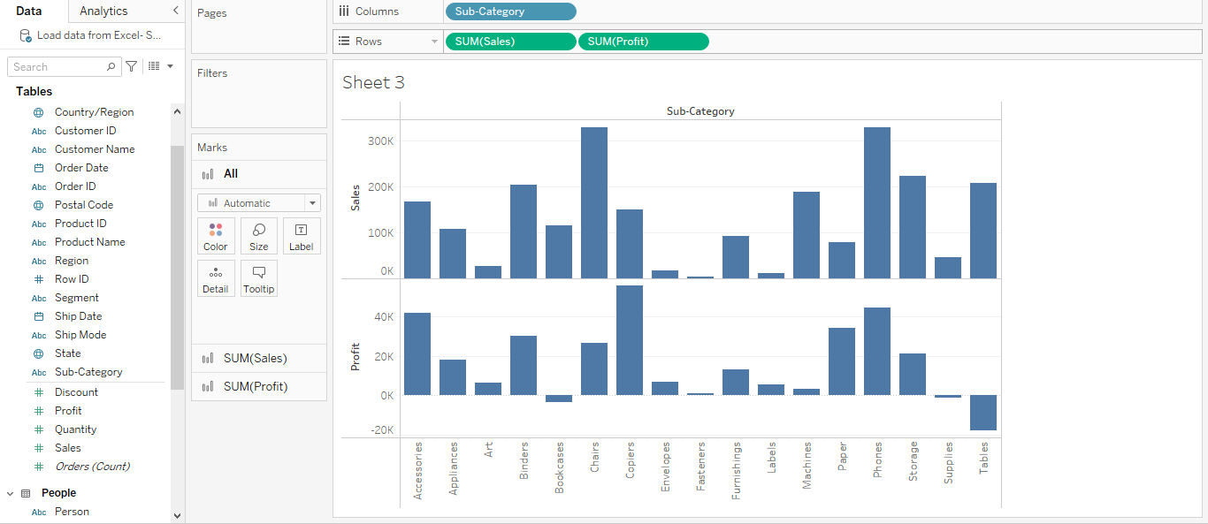

19. Right click on SUM (Profit) pill and check **Dual Axis**

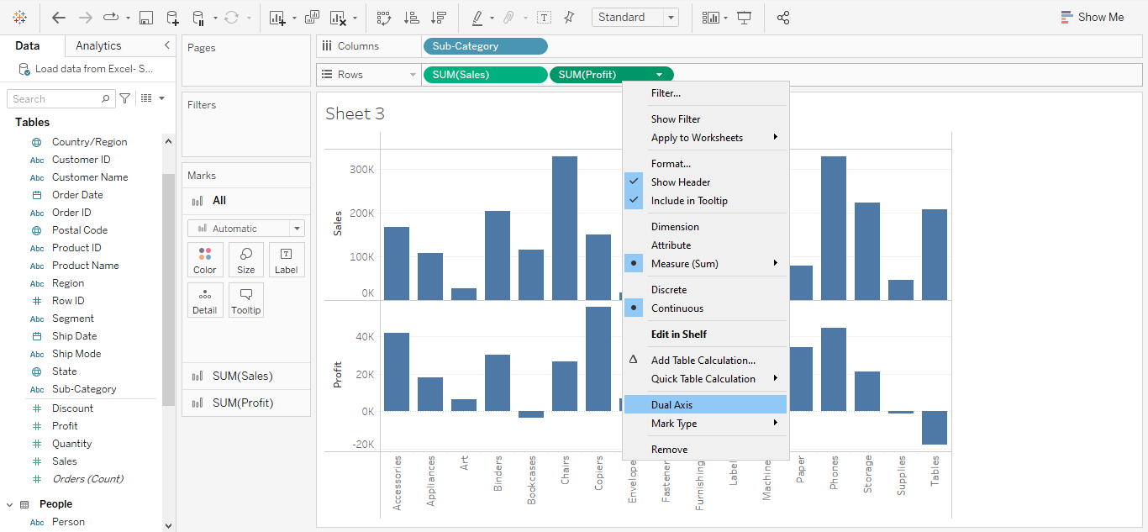

20. To synchronize the axis scale, right-click the **Profit** axis and select **Synchronize Axis**

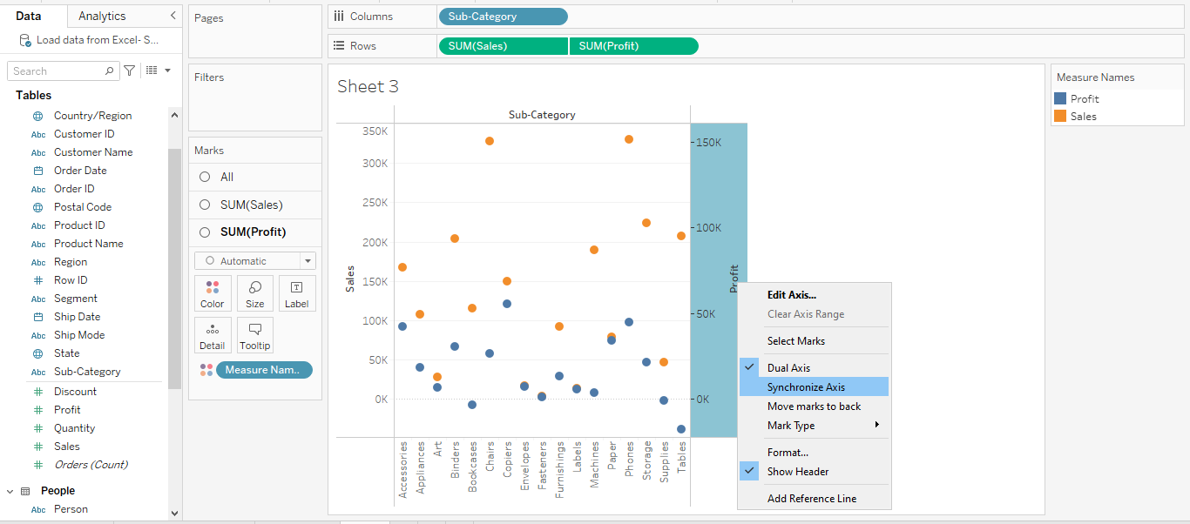

21. To change the mark type, select the **Sales** axis; from the **Marks Card**, select **Bar**

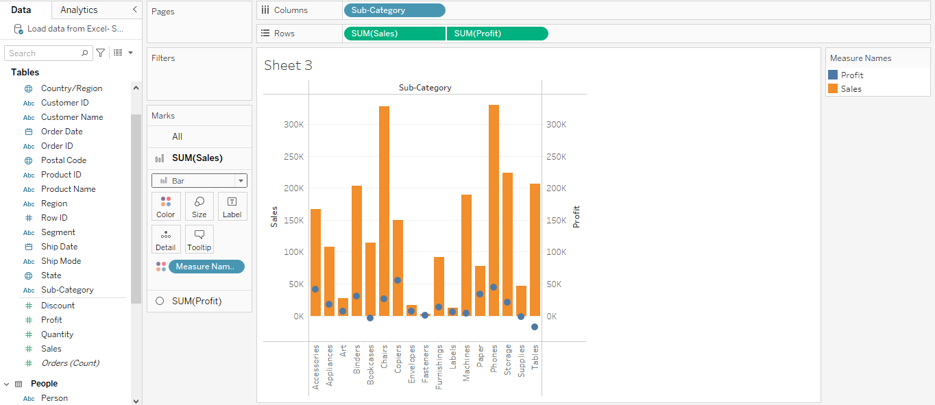

22. Repeat the above process for **Profit,** and select **Line**

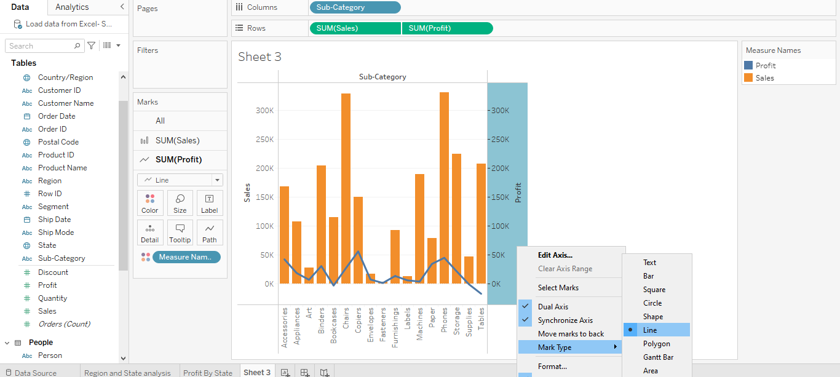

23**.** In the All marks, drag **Category** to **Tooltip**

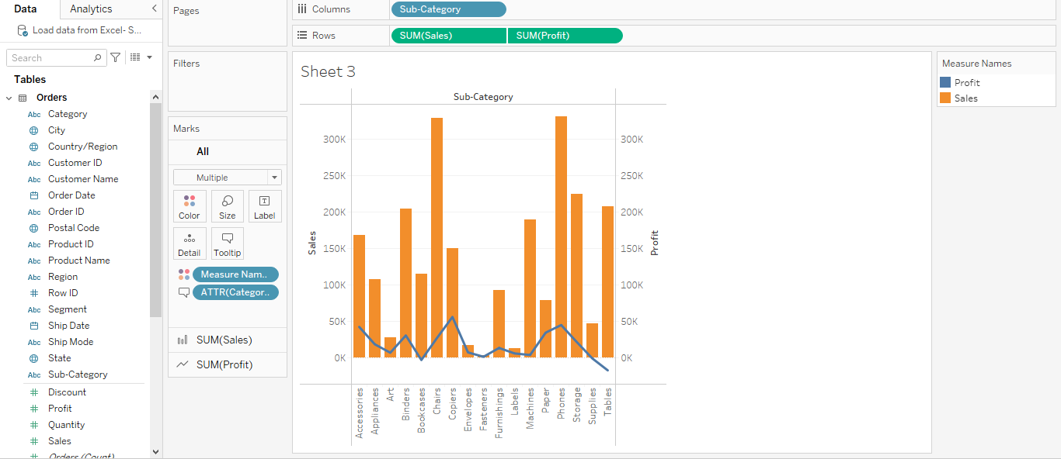

24. Rename the sheet as **Sales and Profit by Subcategory**

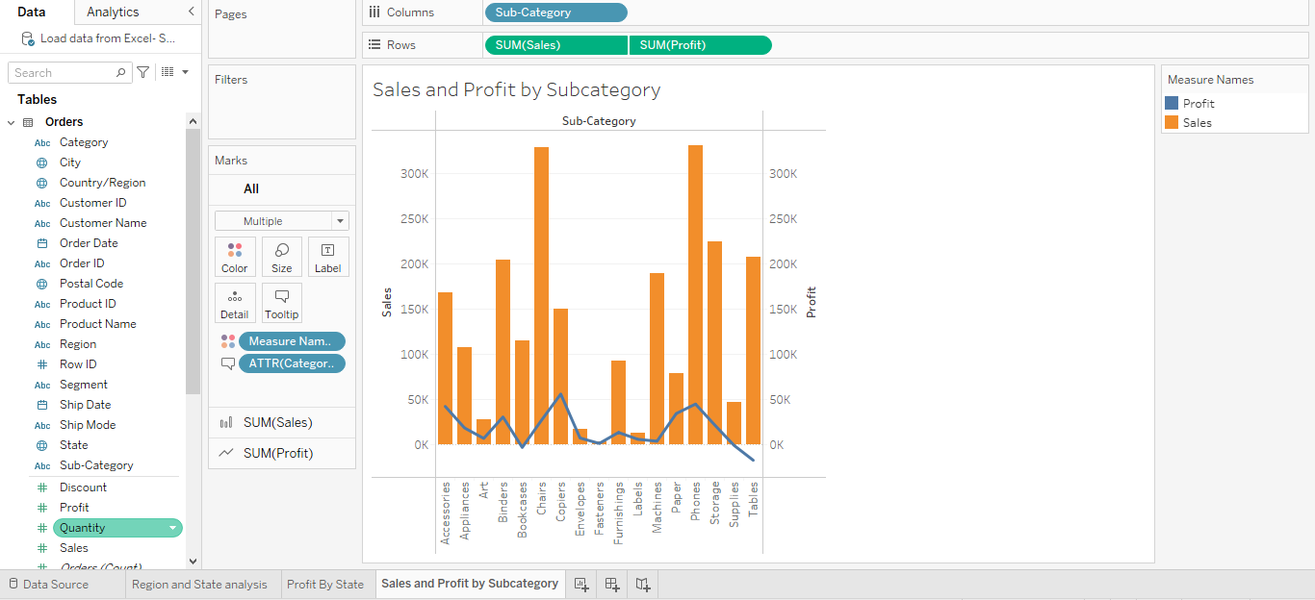

25. Create a New Dashboard

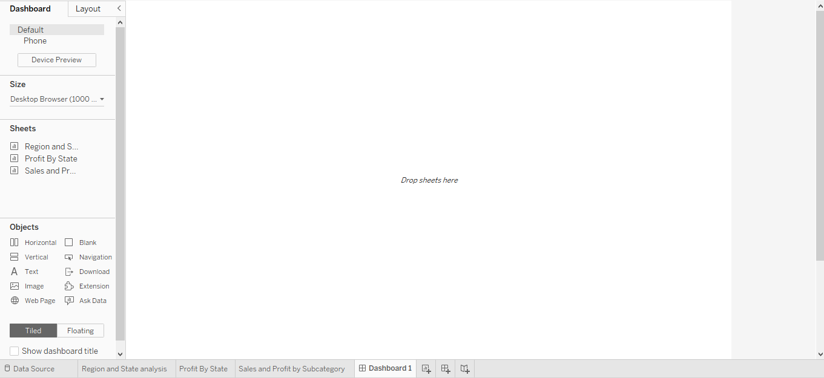

26. Set the Size of the dashboard to **Automatic**

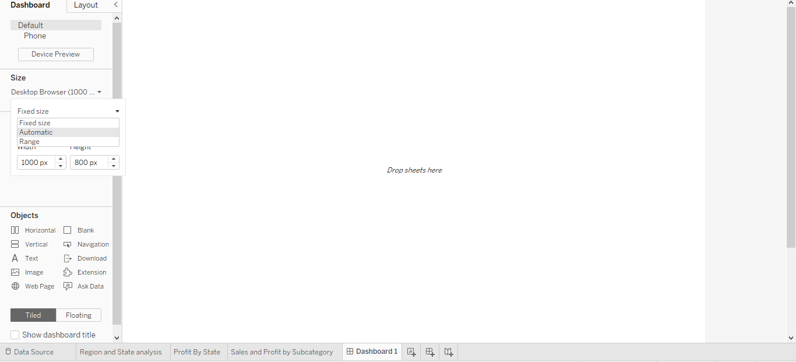

27. To enable the dashboard title, click **Show dashboard title**

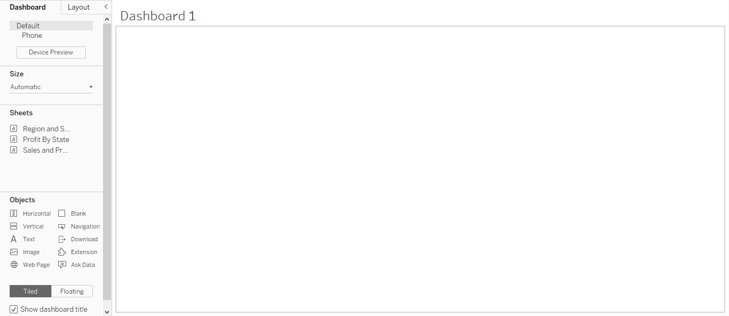

28. Drag the sheets to the dashboard area and resize them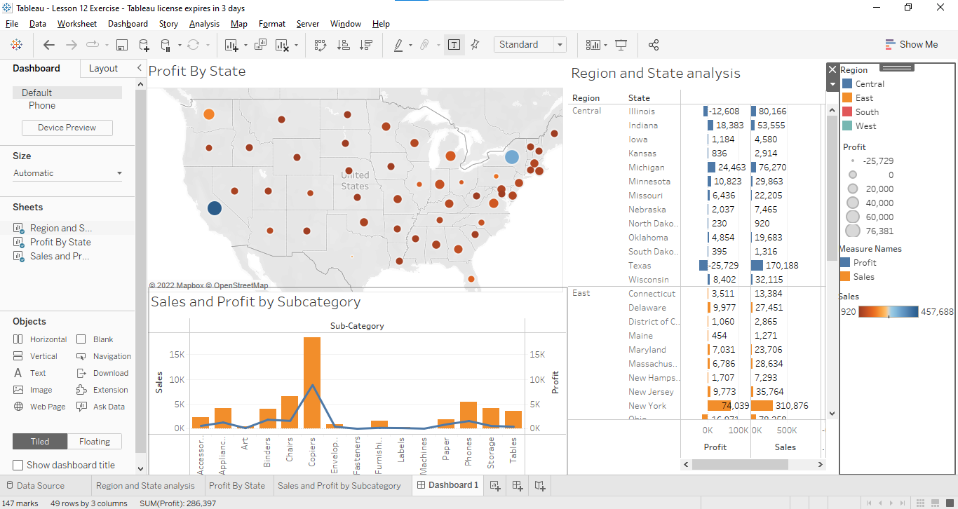

29. To add a filter action, click **Dashboard > Actions**

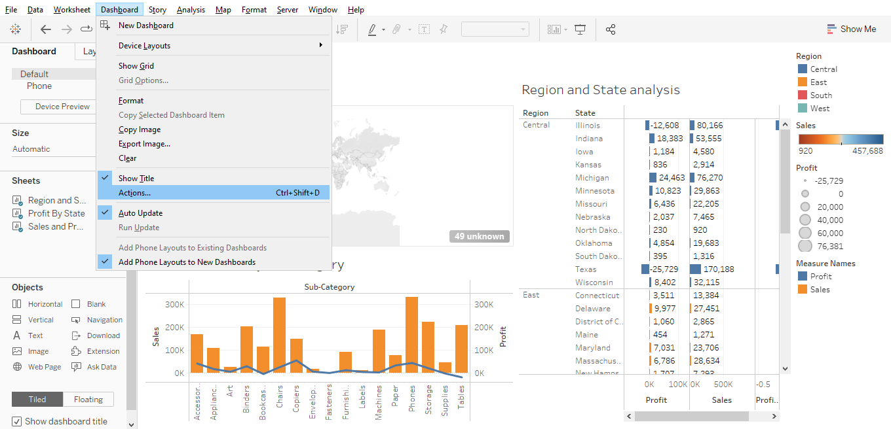

30. In the **Actions** window, select **Add Action > Filter**

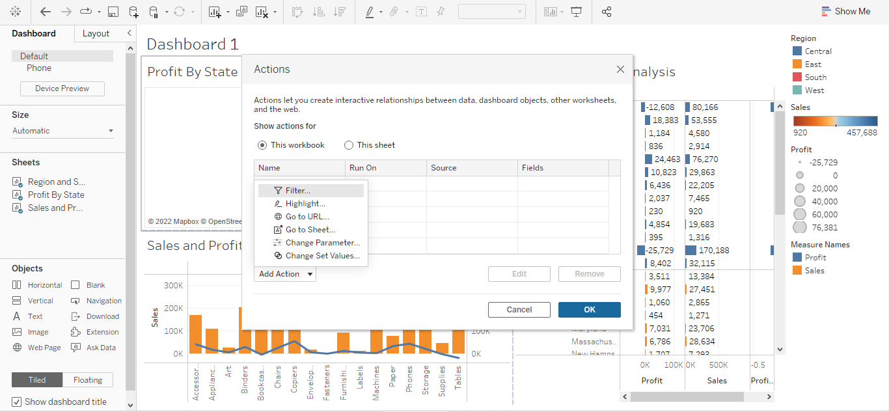

31. In **Add Filter Action**, name this action as **Select to Filter**

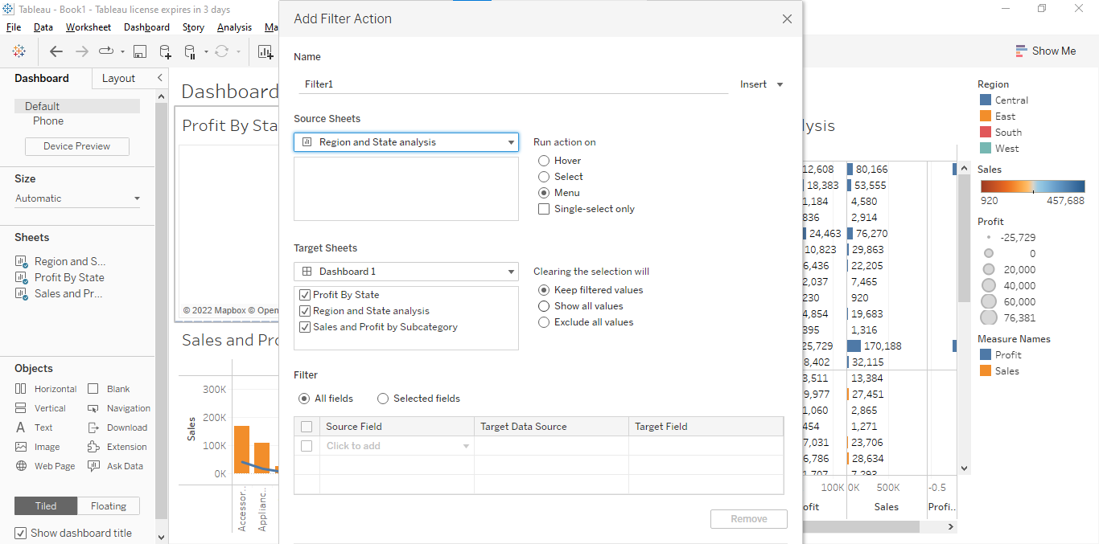

32. Below **Source Sheets**, set source as **Region and State analysis and** choose run action on **Select**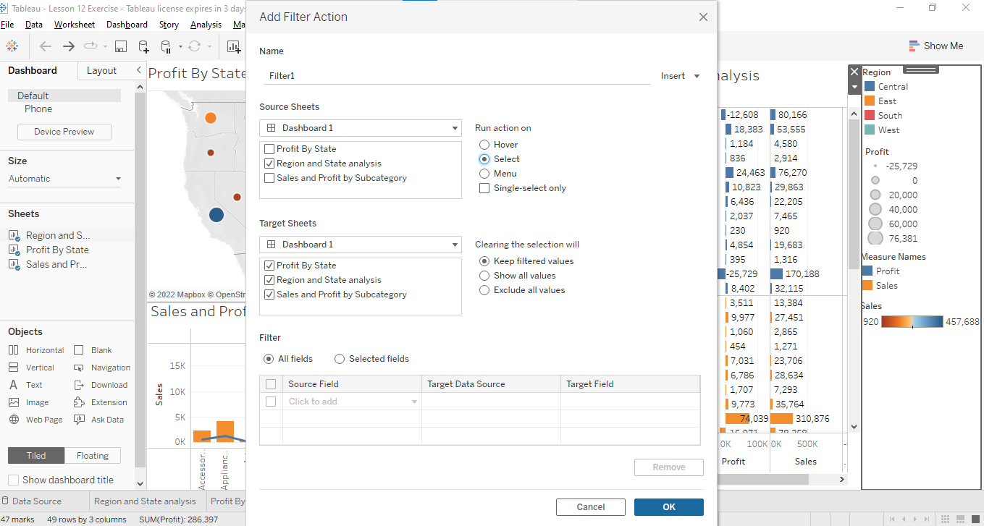

**

34. Select any state on the **Region and State analysis** sheet to run the filter action 38. Save this workbook as **Lesson 12 - Exercise**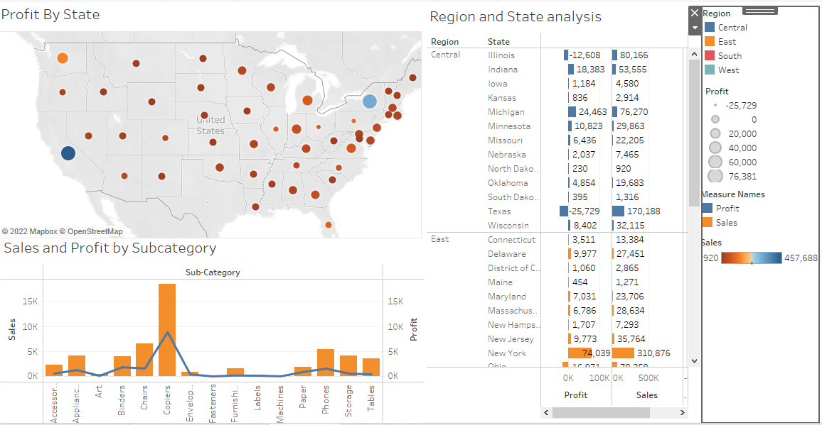

Based on the view, these are the answers to the questions in the problem statement:

**•** What is the overall profit of the Central region?

Answer: **$39,706**

**•** In the South Region, which subcategory recorded the lowest sales?

Answer: **Fasteners**